**Intel Industrial Summer Training**

**Accident Locations on Indian Roads (State: Tamil Nadu)**

**Authors’**

*Mohamed Shafeeq. I*

*3rd year, AI&DS*

*Rajalakshmi Institute of Technology*

[*mohamedshafeeq.i.2021.ad@ritchennai.edu.in*](mailto:mohamedshafeeq.i.2021.ad@ritchennai.edu.in)

*Kishore. M*

*3rd year, AI&DS*

*Rajalakshmi Institute of Technology*

[*kishore.m.2021.ad@ritchennai.edu.in*](mailto:kishore.m.2021.ad@ritchennai.edu.in)

*Mohith Krishna. J*

*3rd year, AI&DS*

*Rajalakshmi Institute of Technology*

[*mohithkrishna.j.2021.ad@ritchennai.edu.in*](mailto:mohithkrishna.j.2021.ad@ritchennai.edu.in)

**Mentors’**

*Dr. O. Pandithurai*

*Institute Mentor*

[*pandics@ritchennai.edu.in*](mailto:pandics@ritchennai.edu.in)

*Dr. G. Sai Krishnan*

*Institute Mentor*

[*saikrishnan.g@ritchennai.edu.in*](mailto:saikrishnan.g@ritchennai.edu.in)

*Mr. S. Vivek*

*Institute Mentor*

[*vivek.s@ritchennai.edu.in*](mailto:vivek.s@ritchennai.edu.in)

***Abstract:***

***This study makes an effort to evaluate road accidents in Tamil Nadu's "Black Spots" and gather year-by-year information. The study focuses on current accident rates and collects the death toll. Even though people are aware of them, there are more accidents on the roads every day. According to the Global Safety Report, more than 1.5 million people die in road accidents globally each year. Road accidents are one of the leading causes of death worldwide. Numerous variables, including the state of the road, its geometry, the car, the pavement, the weather, etc., affect the likelihood of an accident occurring. Each element plays a part in the likelihood of accidents, and there may be many additional situation-specific factors Data on road accidents on an Indian national highway was gathered and geocoded in order to determine the impact of several characteristics on accident occurrence.***

***Keywords: Blackspots, Geocoding, Fatalities.***

**Introduction**

According to the definition of a road traffic accident (RTA), it is "an event that occurs on a way or street open to public traffic; results in one or more people being injured or killed, where at least one moving vehicle is involved." In the current situation, everyone is aware of the fact that more than half of people have been involved in traffic accidents, have died, or have been hurt while traveling on the road. In a traffic accident, pedestrians are often affected in addition to those travelling in the vehicles. Today's globe has made roads and transportation a crucial component of a country's expansion and development.

Everyone uses the roads in some capacity. Although the current transportation system has reduced travel time, it has also increased the chance of fatalities. Every traffic accident results in the death of thousands of people and the terrible injury of countless others. A total of 2 million kilometers of roads exists in India, of which 960,000 kilometers are surfaced and 1 million kilometers are of poor quality. Urban locations experience severe traffic congestion, whereas rural areas have unsurfaced roads. Over 100,000 people die on Indian roadways each year as a result of collisions. Young and elderly, drivers, pedestrians, bus passengers, two-wheelers, and four-wheelers are all among the deceased.

Additionally, it takes into account bicyclists and those who are idling by the side of the road rather than actually traveling. If nothing is done, the future appears to be rather grim given that the population is growing daily and the number of vehicles entering the road system is increasing quickly. Accidents cannot be completely prevented, but their frequency and seriousness can be reduced via scientific study and appropriate engineering interventions. In order to investigate accident causes and implement preventive measures for design and control, traffic engineers must identify systematic accident investigations. Every accident must be examined individually, and accident records must be kept by zone.

These are some of the main issues that Indian highways currently face. This is a really serious matter that needs to be dealt with properly using appropriate statistical techniques. In the modern world, where the number of people who travel by car is sharply rising, there is a desire for more and safer roads in order to have highways free from accidents. The government is taking a lot of initiative to address this problem, but further research is needed. In an effort to make roadways safer for drivers, this study was conducted.

**Data Sources**

The data for this report are taken from state websites, Government agencies responsible for transportation or public safety often collect and maintain accident data. These may include departments such as the Ministry of Road Transport and Highways ([MoRTH](https://morth.nic.in/sites/default/files/Tamil_Nadu.pdf)), Commissionerate of Transport and Road Safety ([CoTRS](https://tnsta.gov.in/tnsta/information.jsp)). They compile data from various sources, including law enforcement agencies, traffic authorities, and official accident reports. Similar private agencies such as SlideShare.net ([Slideshare.net](https://www.slideshare.net/MuraliD1/black-spots-in-tamil-nadu)) and Open City Data ([Data.OpenCity](https://data.opencity.in/dataset/tamil-nadu-crime-data/resource/tamil-nadu-district-and-citywise-road-accident-deaths-in-2019-to-2021) ), etc. also provide valuable information on the accident data. Academic institutions, research organizations, and transportation agencies often conduct surveys and studies to gather accident data. These may include observational studies, driver surveys, or specialized research projects focused on specific types of accidents and road safety.

**Related Work**

The issue of accident locations on Indian roads has been addressed in a number of related studies, and these works have developed solutions using QGIS tools to map these places and anticipate future accidents. Geospatial data and machine learning methods were used in a major work by Gupta et al. (2019) to pinpoint accident-prone regions in Delhi. They merged numerous geographical layers, including road networks, traffic volumes, and land use patterns, with accident data that was gathered from a number of different sources. They were able to identify high-risk areas by using clustering techniques and spatial analysis, and they produced heat maps to show the results. Sharma et al. (2020) conducted another study that combined historical accident data with information on the weather, road features, and traffic to examine the potential of QGIS in accident prediction modeling. According to their findings, spatial analytic approaches based on QGIS may accurately forecast accident-prone regions and support the creation of preventive measures. These connected works show the value of QGIS tools in mapping accident sites on Indian roads and predicting upcoming incidents, helping to improve road safety measures across the nation. Additionally, the Indian government has acknowledged the value of using geospatial tools to improve road safety. Organizations like the Ministry of Road Transport and Highways have undertaken initiatives like the integration of accident data with GIS platforms and the establishment of geospatial databases for accident analysis.

**PROPOSED WORK**

**Blackspots in Tamil Nadu:**

We have chosen Tamil Nadu’s Blackspots and explored 11 years’ worth of data. During this process we have gathered the data for 100 main blackspot regions in Tamil Nadu during the years 2011 – 2013, then using the synthetic data creation AI tool called Gretel and created approximate data for the next 9 years 2014 – 2022. We have then combined these data into a table and have

input the resultant table into the QGIS application from where we have marked the blackspots across the State of Tamil Nadu. After attaining the suitable data sets, we have analyzed all these spots and the reasons for why these accidents occur using the Tableau software.

**Analysis:**

After acquiring the data, we have used the Tableau Software to analyze and create graphs which provide a visual representation of the data acquired. We at first created a bar graph for the year 2022 and we have categorized the chart priority wise where the priority increases with the decrease in number. Similar to the displayed visual in Chart 1, we have created charts for all the 11 years which can be accessed through this link given.

From the total of 100 blackspots, we have shown the common 24 districts containing those major blackspots in here, we can see that there are multiple districts repeated in each priority, these are divided by the blackspots with different priorities in each district, we can see that the bars in priority 5 is high and gets depleted in each consecutive priority. This is due to the fact that priorities increase with decrease in number in the graphs given. This is common to all the graphs given. We have created a predictive graph for the year 2023 as shown in the Chart 2 by using “=FORECAST.LINEAR(x, known_ys, known_xs)” formula in excel, we were able to predict the accident data for 2023, this prediction is based on the past 11 years of data, from 2011 – 2012.

After collecting the data and creating an excel, we have input the data into the QGIS tool and have plotted the blackspots in the Tamil Nadu region as shown in Map 1. Then we have used the Tableau Data Visualization tool and created a visual display of the points as shown in Chart 3.

# 

# CHART 1

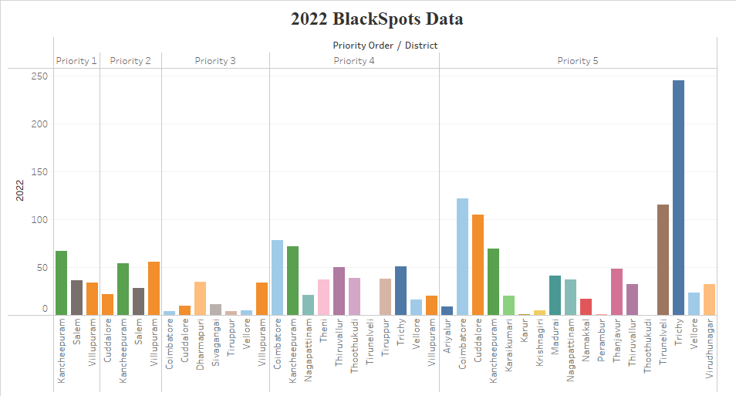

# 

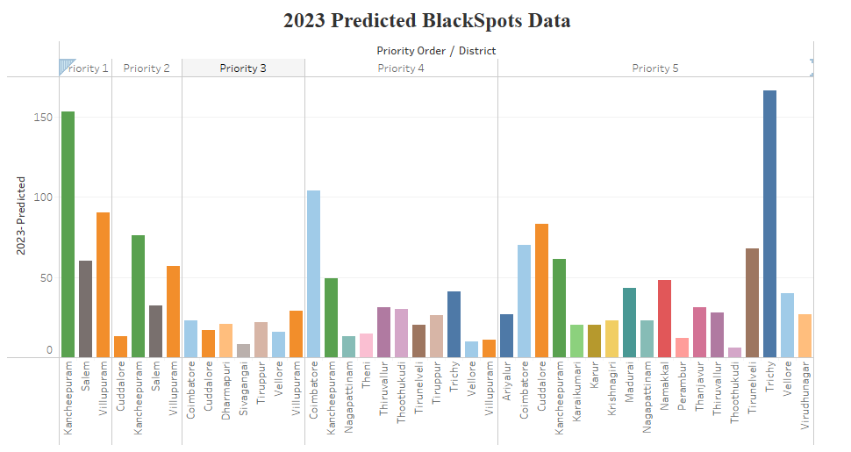

# CHART 2

# 

# MAP 1

# CHART 3

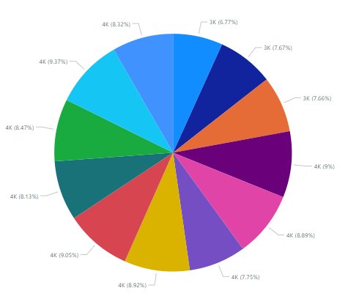



**PRIORITY 1**

**PRIORITY 2**

# Map 2.1 Map 2.2

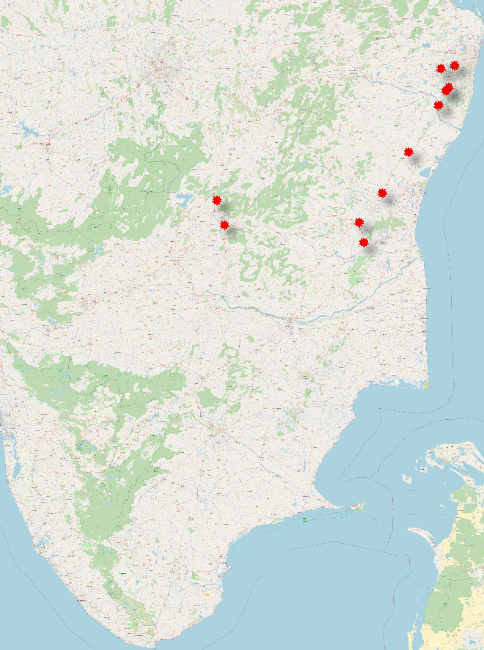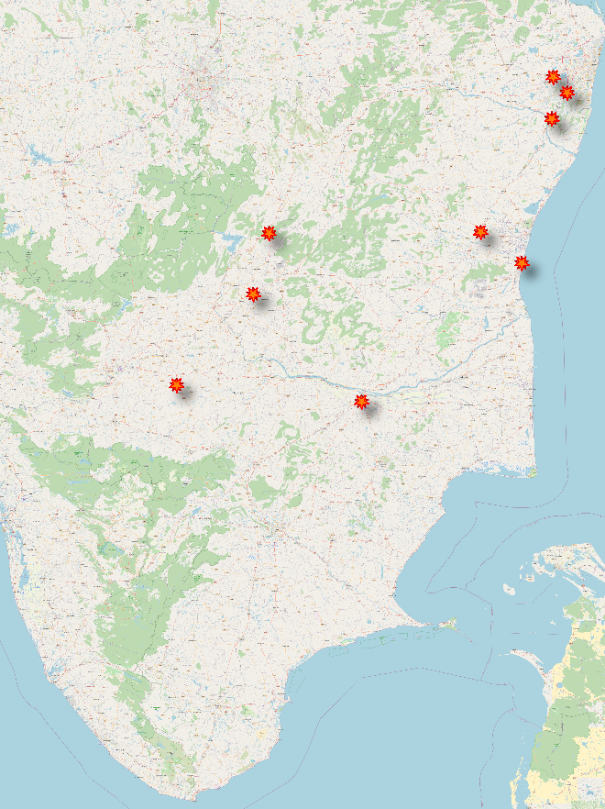

# 

The Map 2.1 indicates The Priority 1, which is the highest priority spot with the greatest number of fatalities. We can see that the Blackspots are relatively less in this Priority when compared to the other Priorities. When we look at the linear representation of spots, we can see that the highway NH32 has the most blackspots. NH32 is the highway which connects Tambaram with Maduravoyal, it also does not have streetlights for 13 years until the 32km stretch was laid. Around 30 accidents were reported on this highway every year almost 40% of them happened between 6pm and 6am, says official data.

The Map 2.2 indicates the high rate of accidents which was occurred in Tamilnadu. While comparing to priority 2 to the priority 1 the accident rates are closely similar but slightly lesser. There is a large number of fatalities in these regions. However, it can be reduced by undergoing a very effective measures to avoid the accidents. Most of the accidents were occurred in the busier roads in the peak hours. These locations need an immediate action to ensure the public safety. Most of the fatalities occurs near the highways and workplaces where people are in rush. Kancheepuram, Salem, Nagapattinam, Tiruppur, Trichy are the districts of Tamilnadu that comes under Priority 2.

**PRIORITY 3**

**PRIORITY 4**

# Map 2.3 Map 2.4

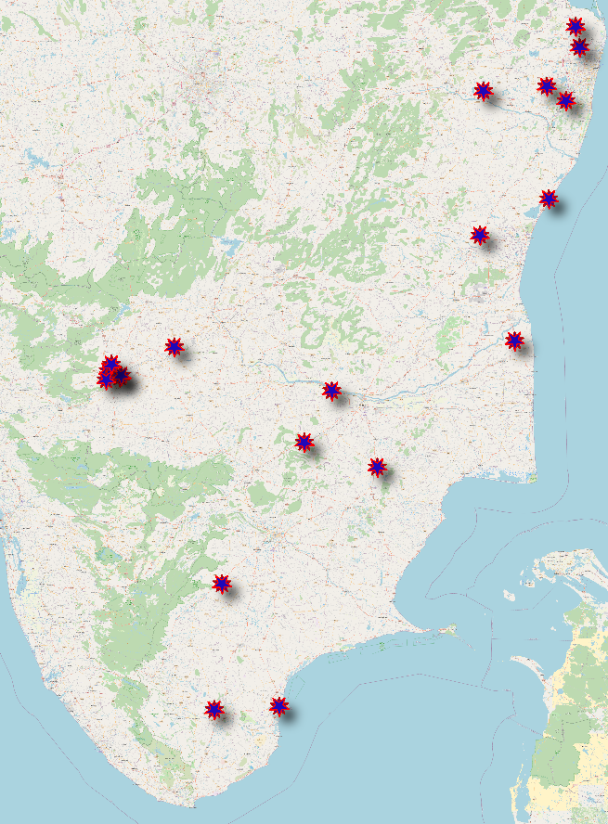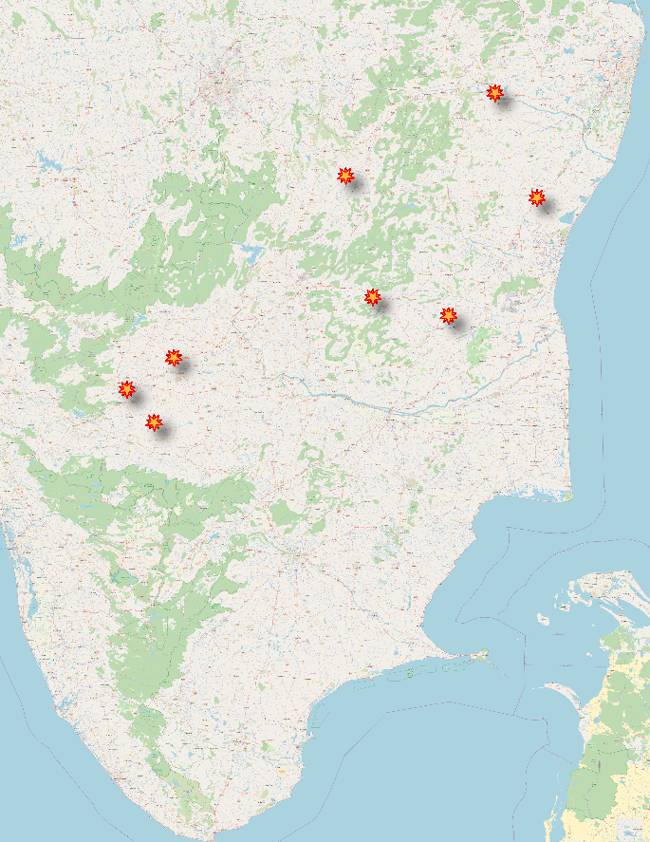

# 

The Map 2.3 indicates the Blackspots which is having moderate accident rate. The frequency of fatalities is in the manner of up and down. However, it can also be suppressed by initiating the safety protocol measures for better survival. The total rate of occurrence of accidents and fatalities are lesser in priority 3 than the priority 1 and priority 2. Vellore, Ariyalur, Tiruppur, Tiruvannamalai were Blackspot districts that are having Priority 3 Blackspots locations. These areas have accidents occurring at a point where it is in the middle of the priority stream.

The Map 2.4 indicates the Priority 4, which is the second last Priorities with fatalities. We can see that many blackspots fall under the Coimbatore region, while the others are scattered all around the State of TamilNadu, this is mostly due to the fact that Priority 4 is normally confused with the other priorities since its close fatality rate to Priority 3 and 5. In this Priority, the fatality rates are relatively higher in the years with less fatalities due to the fact that, this category normally falls under both high and low and moderate in the category.

**PRIORITY 5**

**EMERGENCY ZONES**

# Map 2.5 Map 3

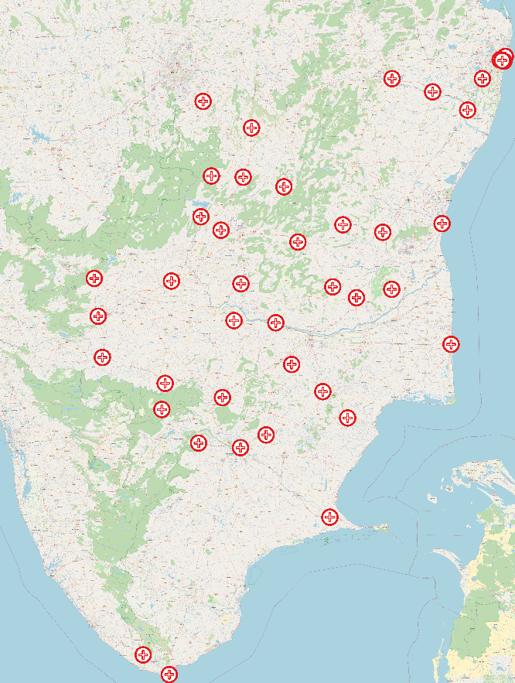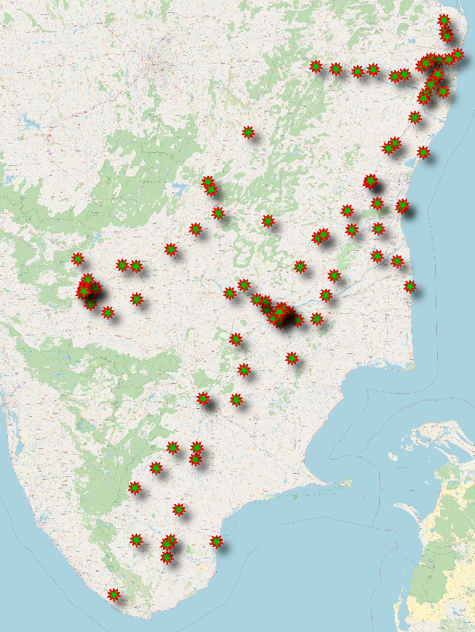

# 

The Map 2.5 indicates the locations which have very low number of accidents. It is identified using the incidents that have occurred in past few years and the severity of the accidents. These places also have very little Fatalities. Here, the accidents are due to the drivers’ error, speeding, mechanical problems, animals and bad weather. To avoid these accidents several measures should be taken, these includes preparing for the bad weather, regular maintenance of the vehicle, obeying traffic rules, etc. The benefits of reducing the occurrence of these accidents such as saving lifesaving money, less injury etc.

The Map 3 are the areas which are established near the accident sites or locations. It is used to ensure the victims safety and emergency operations to save the life. These places are neighboring police stations, fire service and emergency hospitals. The size of the emergency zones varies according the priority level, that is greater the priority greater the service. The identification of the emergency zones is marked using the sign boards and flares. With the help of the data from traffic police FIRs EMRI (Emergency Management Research Institute) increased the number of ambulances and hospitals near the accident-prone zones.

**Reference**

**scribd.com:**

*For Tamilnadu Blackspots locations in the years of 2013,2014,2015*

<https://www.scribd.com/document/439663717/BlackSpots-169-85-64-44-Det2019>

**TNSTA:**

*For Tamilnadu Road Accidents Information*

<https://tnsta.gov.in/tnsta/information.jsp>

**Slideshare.net:**

*For Tamilnadu Blackspots locations in the year of 2011,2012,2013*

<https://www.slideshare.net/MuraliD1/black-spots-in-tamil-nadu>

**Geeks-for-geeks:**

*For Understanding and forecasting the future analysis*

<https://www.geeksforgeeks.org/ml-linear-regression/>

**Research Paper:**

*Assessment and Prioritization of the Critical Factors Triggering Road Accidents in India*

*M. Ashok, M.Tech*

<https://www.iieta.org/journals/ijsse/paper/10.18280/ijsse.110210>

**Health Care Paper:***List of Government Tamil Nadu Accident and Emergency Care Initiative (TAEI) Centres, District wise in Tamil Nadu*

<https://tn.data.gov.in/resource/list-government-tamil-nadu-accident-and-emergency-care-initiative-taei-centres-district>

**Result**

In conclusion on regarding to the topic, we were able to analyze the 100 blackspots from 24 districts where the fatalities have been given for each year with those blackspots respectively. We can see that there are a total of 15 blackspots in Kancheepuram, while there is only 1 blackspot in Dharmapuri which directly coincides to the total population of those two districts where there are totally 5,557,571 people in Kancheepuram (estimates as per Aadhar uidai.gov.in Dec 2023 data) while there are only 1,750,000 people in Dharmapuri. This can be used as an Indication as of how the population plays a vital role in the accident rates in specific areas.



From the above table taken from our dataset, we can see that there is a huge difference between years in total. If we take the economics and the factors like covid and the manufacturing rates, we can see that those factors affect year-wise. This is also seen by the depletion in the fatalities in the year 2019 and 2020 while the years like 2021 are more since the gap in the driving ventures.

## **URL**

To view and access the data files used in this project [*Click Here*](https://github.com/Engineer976/intelunnati_Engineer)